Chapter 8, Problem 1.

For the circuit in Fig. 8.62, find:

(a) i(0⁺) and v(0⁺),

(b) di(0⁺)/dt and dv(0⁺)/dt,

(c) i(∞) and v(∞).

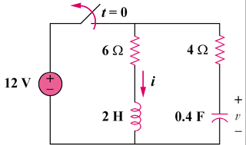

Figure 8.62
For Prob. 8.1.

